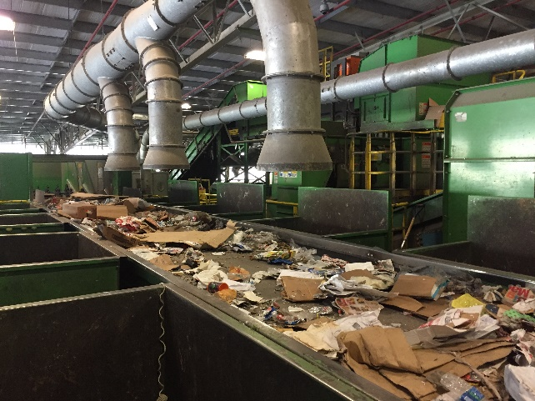

**Recycling is for everyone**

City of Sarasota

**Commercial Recycling**

Recycling is mandatory for Businesses within the City of Sarasota

**Please call any local recycling hauler for a quote**

**The following materials are required by city code to be recycled:**

[](https://www.google.com/url?sa=i&rct=j&q=&esrc=s&source=images&cd=&cad=rja&uact=8&ved=0ahUKEwj1uOPWrYHVAhWF6iYKHYWfA6AQjRwIBw&url=https://www.zazzle.com/recycle%2Bstickers&psig=AFQjCNGh_xcSKnFV8gZ4ziN5mW34YX73zQ&ust=1499866863360123)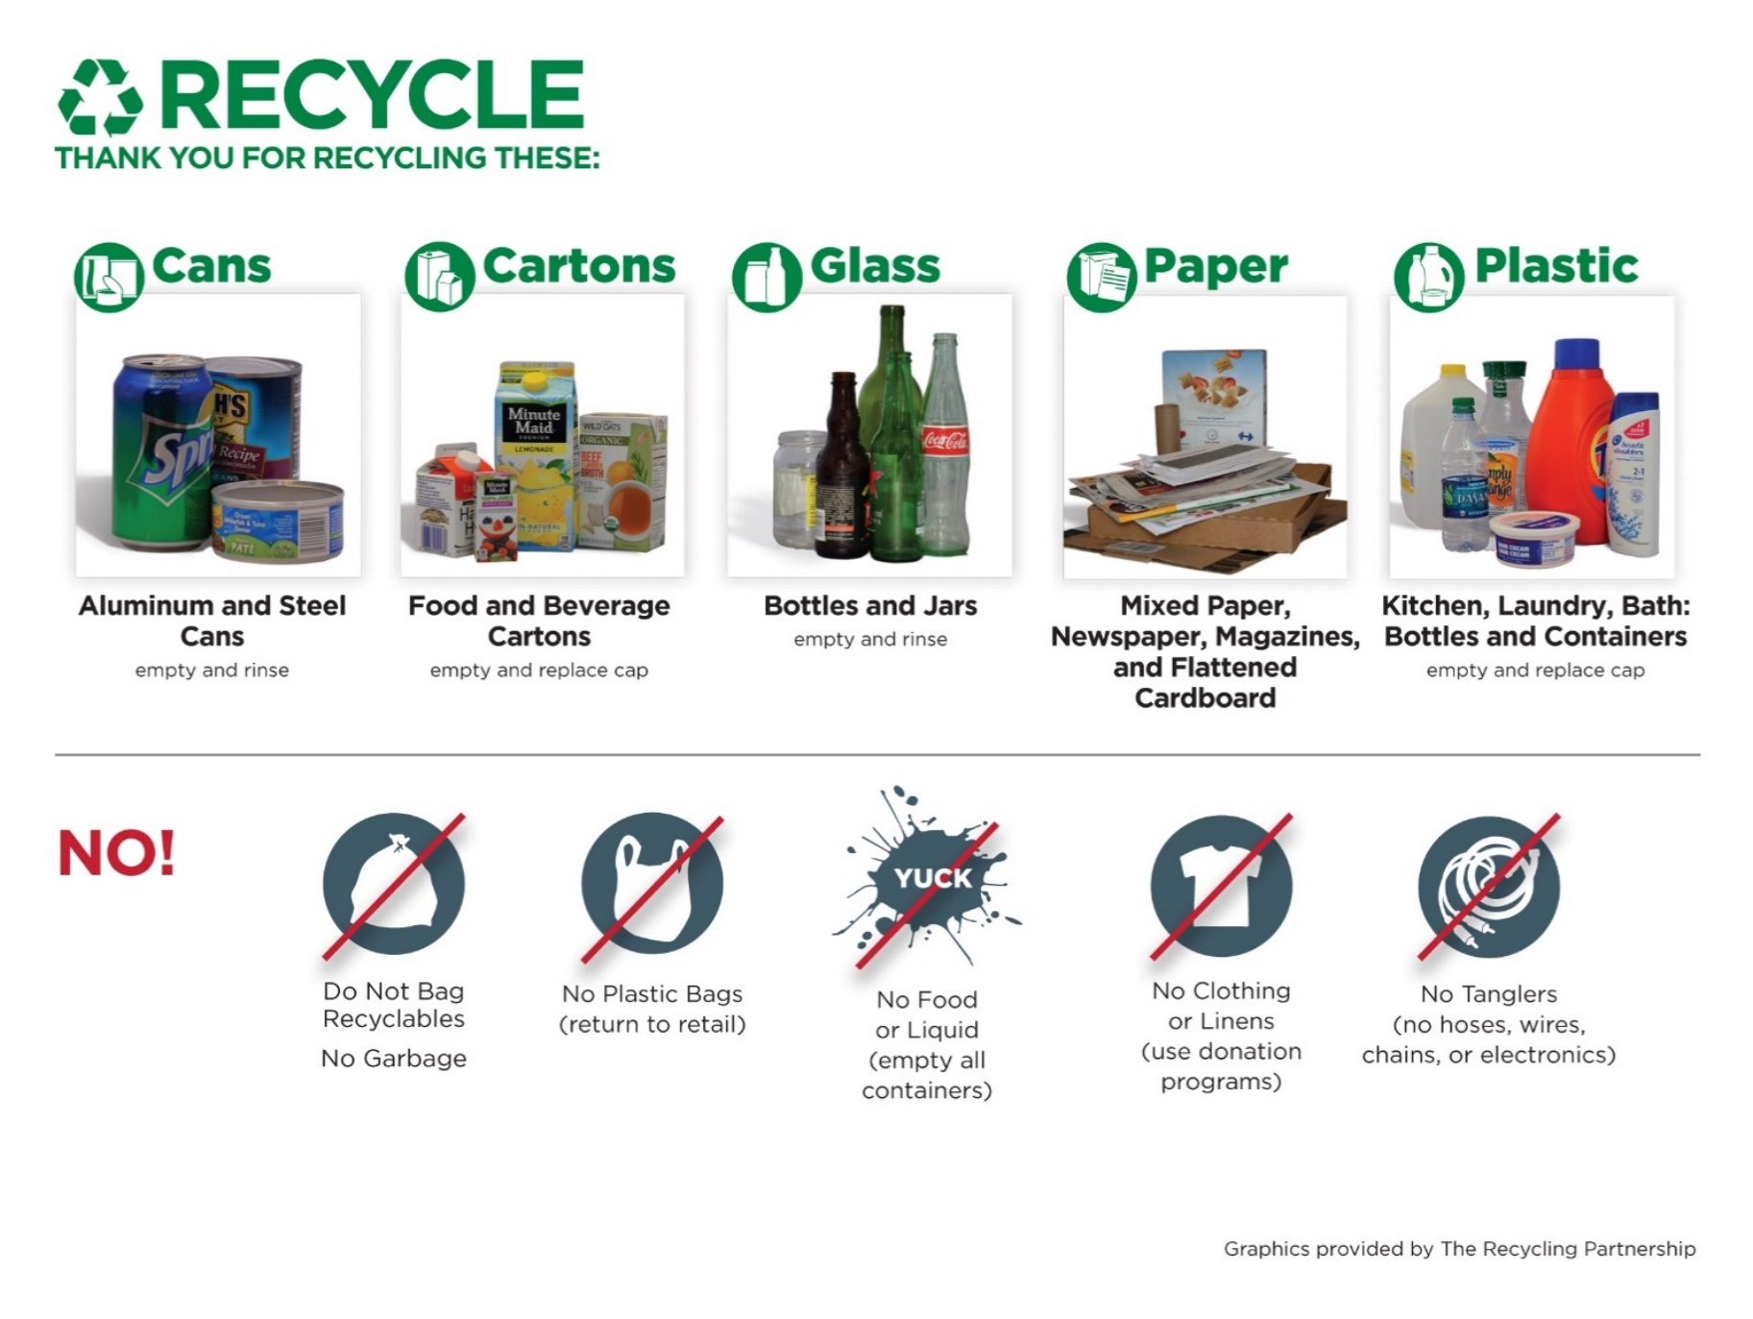

Graphics provided by the Recycling Partnership

Reducing, Re-using & Recycling

■ Saves money

■ Saves resources

■ Is the right thing to do!

We are here to help!

**Call the Sustainability Program at (941) 365-2200, Ext 4203 for answers about recycling or for free, on-site assistance.**

Recycling Service Providers

**You are required to contract with a commercial recycling provider but may use any commercial recycling service provider you would like.**

Numbers to call for recycling haulers



*The city of Sarasota does not endorse any company, and a company’s absence from this list does not imply prejudice or impropriety. We recommend that prospective customers contact several companies for service and price quotes.

City of Sarasota

**Commercial Recycling**